Jenkins Credentials(localhost:8080)

Username:- admin

Password:- 862d1790faa743c9a1db6a1ad1d28b8e

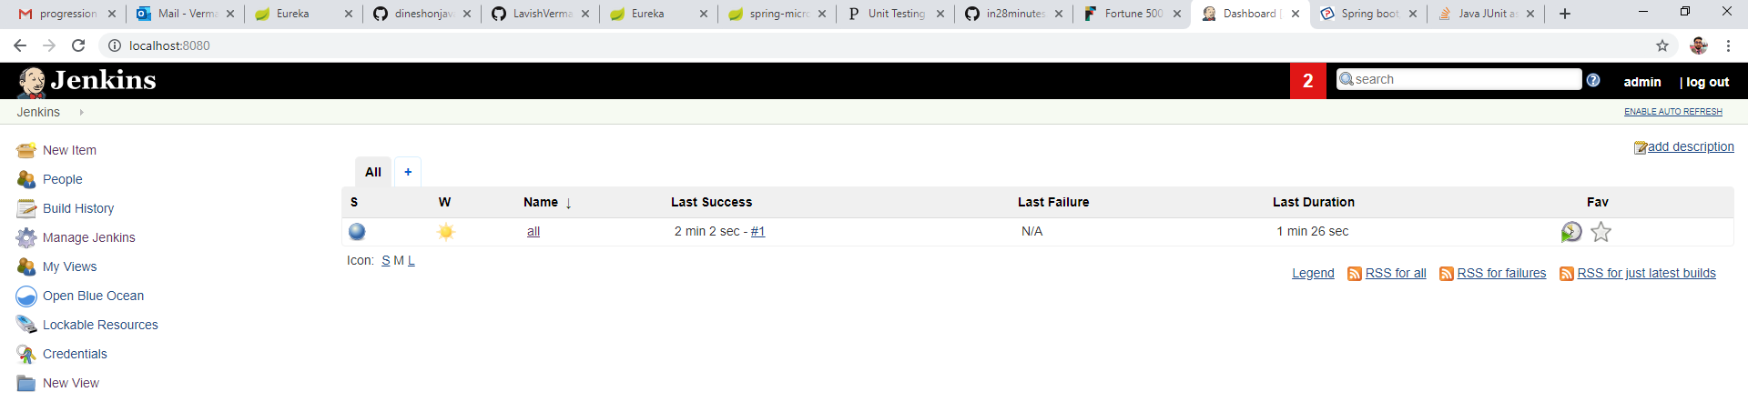When we open localhost:8080 in browser, we will see a repository named “all”.